|  |  |  |  |
| --- | --- | --- | --- |
| **Week one** | **Lunch** | **Dessert** | **Tea** |
| Monday | Chicken goujons with potato wedges and peas | Spiced sponge with custard | Scandinavian beef hash |
| Tuesday | Roast turkey with potatoes and broccoli | Braised apples and sultanas | Baked eggs with vegetables |
| Wednesday | Traditional fish pie and carrots | Orange and cinnamon cake | Tomato pasta with cheese |
| Thursday | Smokey BBQ beef with vegetables and potatoes | Strawberry yoghurt | Lemon chicken with orzo |
| Friday | Irish stew with dumplings and sweetcorn | Melon slices | Tuna pasta bake |

We offer **breakfast** between 8-9am including a variety of fruits, cereals, yoghurts & toast.

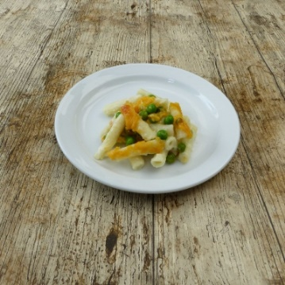

|  |  |  |  |
| --- | --- | --- | --- |
| **Week two** | **Lunch** | **Dessert** | **Tea** |
| Monday | Cottage pie with carrots | Pineapple slices | Herby tomato turkey with potatoes |
| Tuesday | Korma curry with rice | Orange and cinnamon cake | Mascarpone pasta |
| Wednesday | Lamb moussaka with broccoli | Yoghurt | Beef chilli |
| Thursday | Pizza with diced Peppers | Poached Pears | Chicken and pea pasta |
| Friday | Tomato fish pasta with peas | Melon slices | Pea and pepper frittata |

|  |  |  |  |
| --- | --- | --- | --- |
| **Week three** | **Lunch** | **Dessert** | **Tea** |
| Monday | Tikka turkey with rice | Pineapple slices | Lamb and chickpea stew |
| Tuesday | Shepherd’s pie with peas | Yoghurt | Chicken and tomato orzo bake |
| Wednesday | Roast chicken with potatoes and carrots | Poached pears | Spanish tortilla |
| Thursday | Fish fingers with potato wedges and broccoli | Flapjack | Cheesy peasy pasta |
| Friday | Pasta Bolognese with sweetcorn | Yoghurt | Mini jackets with sweet chilli chicken |

**Mid-morning & afternoon snacks** include a fruits, crackers, breads and dips.

[Type a quote from the document or the summary of an interesting point. You can position the text box anywhere in the document. Use the Drawing Tools tab to change the formatting of the pull quote text box.]

[Type a quote from the document or the summary of an interesting point. You can position the text box anywhere in the document. Use the Drawing Tools tab to change the formatting of the pull quote text box.]

[Type a quote from the document or the summary of an interesting point. You can position the text box anywhere in the document. Use the Drawing Tools tab to change the formatting of the pull quote text box.]

